Templatse No. | 01
Version No. | V 1.0
Release Date | 05-MAR-2021

E-Invoice Process Document
Project Name: JSW New Era
Document No.: 001
Version No.: V 1.0

Contents
1. E-invoice Introduction 3
1.1. Introduction 3
1.2. Authentication API 3
1.3. Generate IRN API 3
1.4. Cancel IRN API 4
2. Objective & Scope Of E-invoice 4
3. E-invoice Json Parameters 4
3.1 Sample Request Payload 4
3.2 Sample Request Payload 7
3.3 Generation Process 7
4. E-invoice Scenarios 8
5. Tax Scenarios Covered in E-invoice 8
6. Conclusion 8

E-invoice Introduction

Introduction
E-Invoice APIs are used to interact and exchange the data between Taxpayer/GSP systems and the e- Invoice system. The data that is exchanged is always encrypted and the RESTful APIs are exposed over the SSL. The APIs can be accessed only after a successful token-based authentication.
APIs that receive the data for addition or updation use the http POST method and those which provide data based on certain inputs use GET method. Eligible API user has to complete a self-registration process to get the required credentials such as client id, client secret, user id and password. Using these credentials, one must call the authentication API to get authenticated with the NIC’s e-Invoicing API system.
On successful authentication, an authentication token and SEK (Session Encryption Key) is generated by the system and provided to the user. These two are valid for 1 hour on the sandbox environment and for 6 hours in the production environment.
E-Invoice API has two set of credentials – Client ID, Client Secret (For GSPs) and User ID, Password (For Taxpayers with GSTIN). If the taxpayer is enabled to access the API directly, then they will get Client ID, Client Secret that can be used PAN India for all sister concerned GSTINs with same PAN. API Credentials for Sandbox is available on registration in the API sandbox portal. And API Credentials for Production is available after completion of the boarding process.

Authentication API
Access of API requires authentication using taxpayer’s credentials. Hence this API will be triggered through a scheduler which will execute at every 60 minutes in UAT and 360 minutes in Productions. After receiving the Auth Token and Sek system will save the values in system parameters table to use the same when it requires while requesting other services.
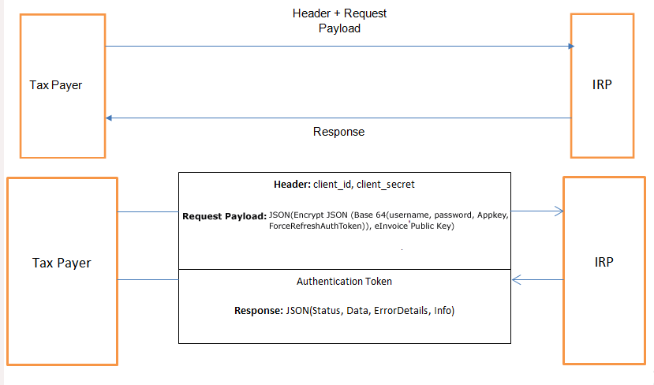
N.B – TaxPayer : iPortman POS System.

Generate IRN API
This API is for registering the invoice or generation of the invoice reference number - IRN. Here the request payload has to be as per the e-invoice JSON schema given in the portal. User can view the image that shows how the request header, request payload and the response payload are exchanged between the iPortman POS system and the IRP system.
The Service will be enabled for all types of invoices like
- Final Invoice: INV
- Credit Note: CRN
- Debit Note: DBN
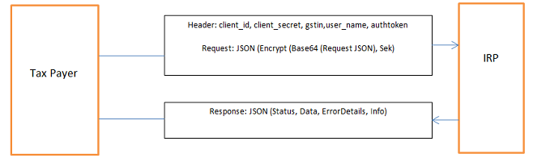

N.B – TaxPayer : iPortman POS System.

Cancel IRN API
This API is used for cancelling an e-Invoice within the stipulated time (24 Hrs.) by passing the IRN. This API uses the POST method.
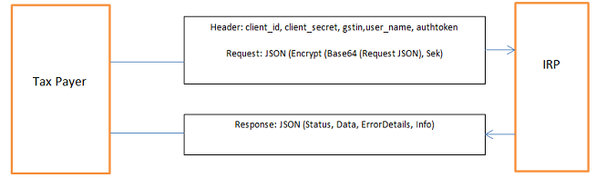

N.B – TaxPayer : iPortman POS System.

Objective & Scope Of E-invoice
The objective of the E-invoice is to generate the generate the invoices in electronic mode by posting the invoices into GST portal. As project scope and GST Complains requirements ASP (Application Suvidha provider) will integrate the system with GST portal to generate the e-invoices automatically through API integration

E-invoice Json Parameters

Sample Request Payload
Sl. No. | Field Name
Transaction Details
1 | Tax Scheme
2 | Supply Type
3 | Reg Rev
4 | ECOMM GSTIN
5 | IGST On Intra
Doc Details
6 | Invoice Type
7 | Invoice No
8 | Invoice Date
Seller Details
9 | Seller GSTIN
10 | Seller Legal Name
11 | Seller Trade Name
12 | Seller Address Line 1
13 | Seller Address Line 2
14 | Seller Location
15 | Seller Postal Code
16 | Seller State Code
17 | Seller Phone Number
18 | Seller Email
9 | Seller GSTIN
10 | Seller Legal Name
11 | Seller Trade Name
12 | Seller Address Line 1
13 | Seller Address Line 2
14 | Seller Location
15 | Seller Postal Code
16 | Seller State Code
17 | Seller Phone Number
18 | Seller Email
Buyer Details
19 | Buyer GSTIN
20 | Buyer Legal Name
21 | Buyer Trade Name
22 | Buyer Place Of Supply
23 | Buyer Address Line 1
24 | Buyer Address Line 2
25 | Buyer Location
26 | Buyer Postal Code
27 | Buyer State Code
28 | Buyer Phone Number
29 | Buyer Email
30 | Dispatch Details
31 | Shipping Details
Item Details
32 | Item Sl No.
33 | Product Description
34 | Is Service
35 | HSN Code
36 | Bar Code
37 | Quantity
38 | Free Quantity
39 | Unit
40 | Unit Price
41 | Total Amount
42 | Discount
43 | Pre-Tax Value
44 | Ass Amount
45 | GST Rate
46 | IGST Amount
47 | CGST Amount
48 | SGST Amount
49 | Cess Rate
50 | Cess Amount
51 | Cess Non Adv Amount
52 | State Cess Rate
53 | State Cess Amount
54 | State Cess Non Advl Amount
55 | Other Charge
56 | Total Item Value
57 | Order Line Reference
58 | Origin Country
59 | Product Serial Number
Value Details
60 | Ass Value
61 | CGST Value
62 | SGST Value
63 | IGST Value
64 | Cess Value
65 | State Cess Value
66 | Discount
67 | Other Charge
68 | Round Off Amount
69 | Total Invoice Value
70 | Total Invoice Value Fc
71 | Batch Details
72 | Attribute Details
73 | Pay Details
74 | Reference Details
75 | Additional Document Details
76 | Export Details
77 | Eway Bill Details
78 | Ass Value
79 | CGST Value
80 | SGST Value
81 | IGST Value
82 | Cess Value
83 | State Cess Value
84 | Discount
85 | Other Charge
86 | Round Off Amount
87 | Total Invoice Value
88 | Total Invoice FC

Sample Request Payload
Sl. No. | Field Name
1 | Acknowledgement Number
2 | Acknowledgement Date
3 | IRN
4 | Signed Invoice
5 | Signed QR Code
6 | Status
7 | E Waybill No.
8 | E Way Bill Date
9 | E Way Bill Valid Till
10 | Remarks

Generation Process
- To generate the e-invoice From IPortman system invoice need to be approved by the user.
- After Approval Api will trigger the with invoice details to GST portal.
- Once in GST portal Invoice posted if all required pre-requisite conditions satisfied then IRN will generate.
- After Successful posting of invoice record IRN, Ack No, Ack Date, Qr details etc… will generate and the same details will be stored into IPortman system.
- After storing the details user can take the invoice print out with IRN number and QR Code as authorised invoice from the GST portal.
Sl. No. | Field Name
1 | Acknowledgement Number
2 | Acknowledgement Date
3 | IRN
4 | Signed Invoice
5 | Signed QR Code
6 | Status
7 | E Waybill No.
8 | E Way Bill Date
9 | E Way Bill Valid Till
10 | Remarks

E-invoice Scenarios
Scenarios Covered under E-invoice generation Process.
- E-invoice Generation for invoice
- E-invoice Cancelation for Invoice
- E-invoice Generation for Credit Note
- E-invoice Cancelation for Credit Note

Tax Scenarios Covered in E-invoice

Conclusion
After Successful generation of E-invoice IRN, ACK NO,ACK DATE QR CODE will be print in invoice system.

